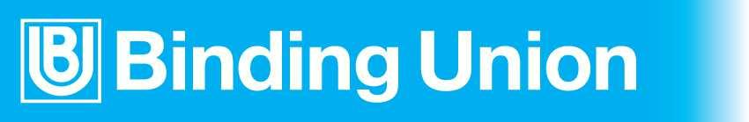

UNI CATALOG 2015

(Rev.1501)
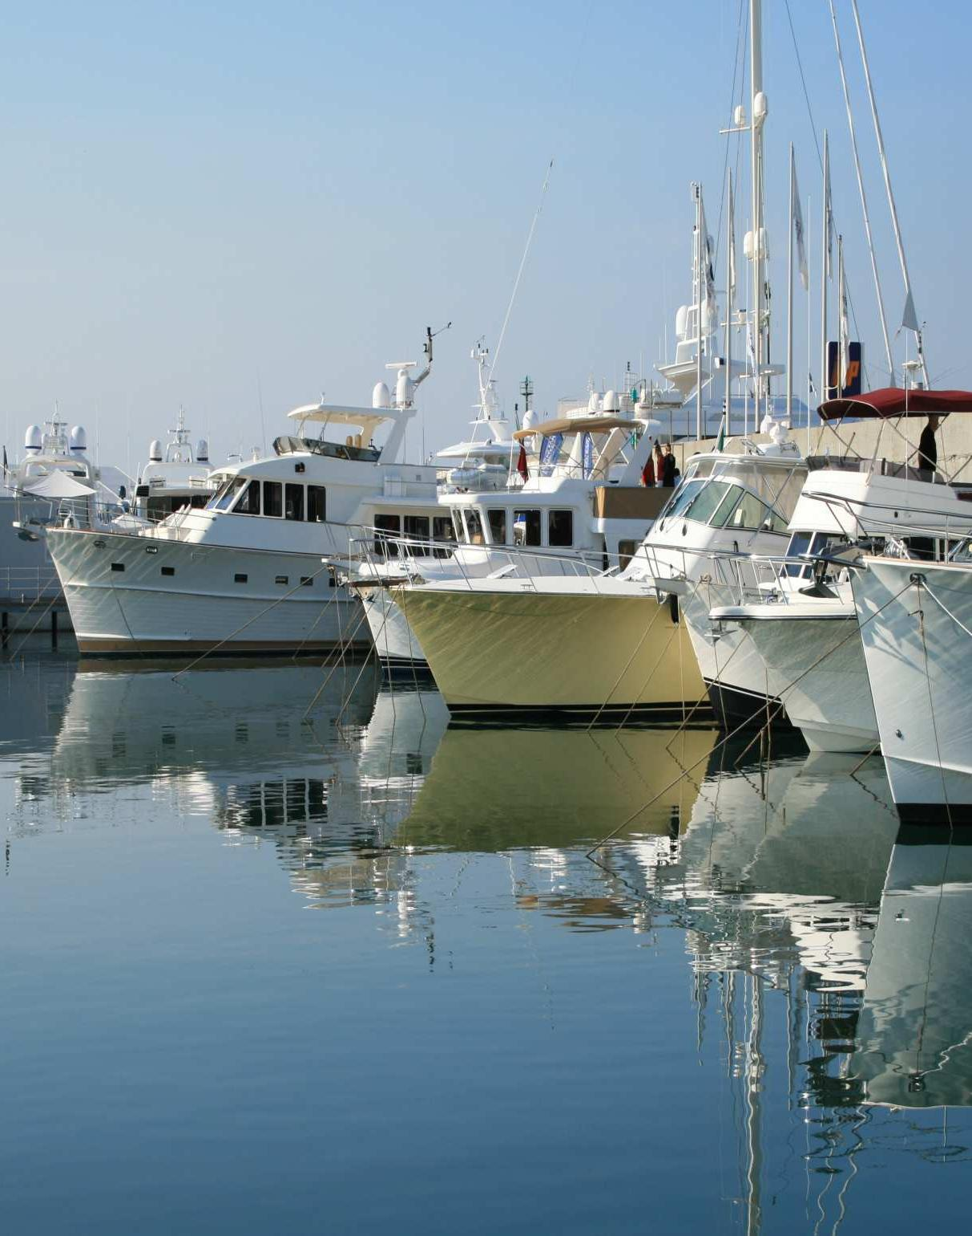

Binding Union srl – via Cuorgnè, 21 – 10156 Torino – Italy – tel. +39.011.2625414 – Fax +39.011.2625428 –www.binding.it – 1

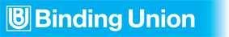

OUR PHILOSOPHY

It is since 1975 that Binding Unit has been designing and producing professional measure instruments.
Nowadays, the offered products wide range allows us to satisfy the most varied applications. Our firm’s fundamental rules of our firm have always been the development of reliable solutions to real problems and to pay attention to the customer. This philosophy and the engagement to employ avant-garde technologies are recognised at international level.

Automation Marine Lift
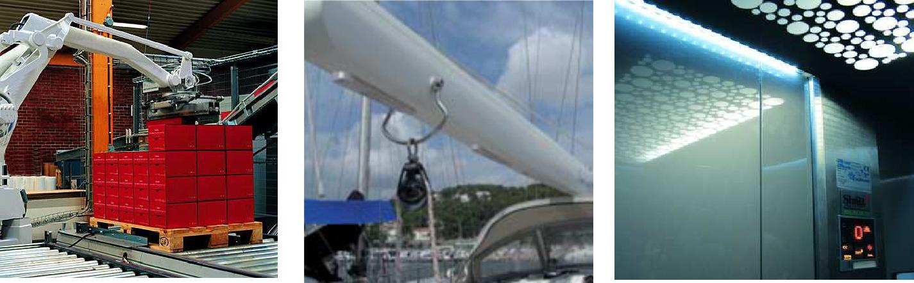

www.binding.it
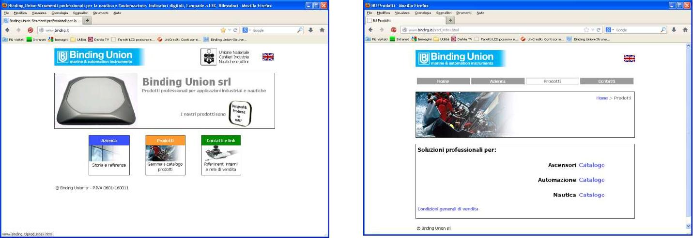

Binding Union srl – via Cuorgnè, 21 – 10156 Torino – Italy – tel. +39.011.2625414 – Fax +39.011.2625428 –www.binding.it – 2

LIGHTING
Main illuminating engineering sizes

Luminous flux, lumen (lm).

Represents the light energy quantity emitted in the space from a source in the time unit.

Illumination, lux (lx).

Represents the light quantity emitted form a source placed on a surface. Where the illumination produced by 1 lumen that falls in a uniform way on a 1 sm surface is equal to 1 Lux.

Colour temperature, kelvin degrees (°K).

Quantifies the light shade. A source chromatic aspect is defined as colour temperature.

Light shade.

This shows the colour temperature graduating from Warm to cold. The light shade is equal to the colour temperature + colours chromatic efficiency index (CRI).

The shade has been standardized (UNI 12464) in three groups in the following table:

Pos. | Range | Indications | References
1 | Up to 3300 °K | Shows Warm tones | Candle light
2 | From 3300°K to 5300°K | Shows daily light | Sun at midday
3 | Over 5300° K | Shows cold light | Cloudy sky

Light sources normally used in plants

Lamp type | Medium efficency | Power common used | Medium last
Incandescent | 13…15 lm/W | 25 W | 1000 hours
Fluorescent | 60…80 lm/W | 10, 15, 20 W | 8000 hours
Halogen | 16…20 lm/W | 10, 20, 50 W | 2000 hours
White Led | 50…110 lm/W | 2…6 W | 50.000…80.000 hours

LED, in comparison with the conventional light sources give a number of advantages, as:

- Small size

- Low heat dissipation

- Long last

- Possibility to regulate the lighting in a continuous way and with different colours

- A substantial power saving, with the reduction of the power supply conductors section

- Higher safety in place with explosion risk

- Higher safety against hits and vibrations

- No ultraviolet rays emission and no noxious gas

Nowadays, LED can easily take the place of other kind of lamps, reducing the electric absorption and improving the lighting.

Furthermore, most of them have the big advantage to work with voltages between 10 and 30 Volt, so they do not suffer from the electric plant voltage drop or surplus, with the consequent lighting alterations and breakage, that happens with other type of lamps.

Real lighting form Binding Union point of view

Many lamps producing firms, supply the luminous flux data (Lumen), even though it shows the source lighting and not the real one, it can happen to loose even the 40 …50%, through the lens that made up the lamp.

Binding Union refers to Lux, the unit that measures the lighting on a certain surface at a fix distance form the lighting source, so that the real lighting is valued.

So, measuring the lamp efficiency in lux, the data supplied are much more real than the ones supplied by other competitors, and makes easier the designer work that have to establish the quantity and models needed in a particular zone.

Binding Union srl – via Cuorgnè, 21 – 10156 Torino – Italy – tel. +39.011.2625414 – Fax +39.011.2625428 –www.binding.it – 3

LAMPS
IRIS - LED spotlight, for underwater and exterior use

Applications
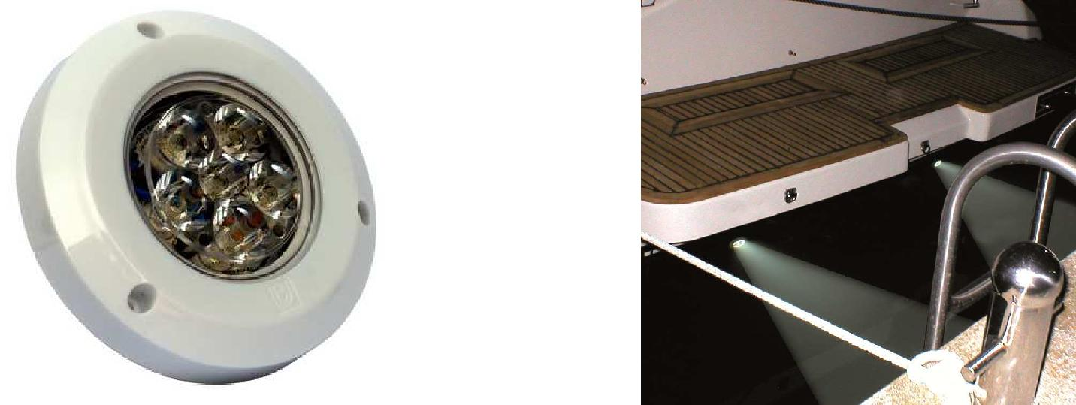

IRIS, underwater LED spotlights, usable also out of the water

Robust and elegant (polycarbonate) case allow a quick and economic installation. For the mounting it is necessary a single hole (from 18 mm) for the Power Supply cable passage, it is also possible to avoid this hole using the spacer AV0467.
The frames are interchangeable and available in white, black and chromed colours, for surface and recessed mounting, with screw fastening. No connection to the anodes.
Suitable for little bridges, roll bars, awnings, cockpits, motor vain, kitchens and baths.

IRIS Plus, very bright LED spotlights for exclusive underwater use

Technical specifications Dimensions

- Polycarbonate case (Inox optional)
• Emission angle 30° (15° for IRIS Plus)
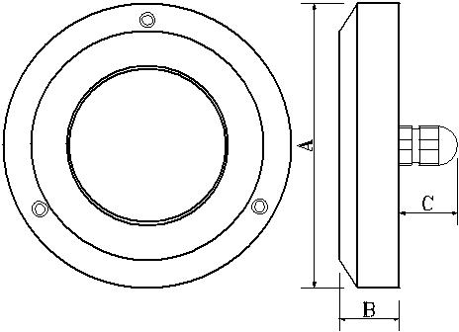
- White light (8000°K) or blue

- Sea cable from 2 m
• Power Supply: 10…30 Vdc • High protection class IP68
• Luminous intensity: 800 lux at 1 m (2230 lux IRIS Plus)

- Protected against polarity inversion
• Protected against power surges
• Low power consumption: 4 W, (6W IRIS Plus) long duration

- Work life: 30.000 hours @ 25°C

- Dimensions: 110 (A) x 23 (B) x 20mm (C)

Models | Description | AV0467
LIR611KW | IRIS - Spotlight, white light (dual white frame for surface and recessed mounting)
LIR611KB | IRIS - Blue light spotlight (dual white frame for surface and recessed mounting)
LIR9PKW10 | IRIS Plus - Spotlight, white light (completed of surface white frame)
LIR9PKB10 | IRIS Plus - Spotlight, blue light (completed of surface white frame)
AV0467 | Spacer to avoid the cable hole, dim. 110x30mm
AV0404 | White recessed mount frame | AV0427
AV0405 | White surface frame
AV0407 | Black recessed mount frame
AV0408 | Black surface frame
AV0409 | Chromed recessed mount frame
AV0410 | Chromed surface frame
AV0427 | AISI316 stainless steel surface mount frame
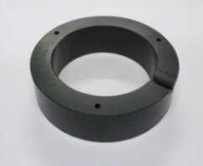
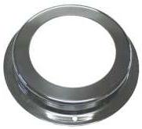

Binding Union srl – via Cuorgnè, 21 – 10156 Torino – Italy – tel. +39.011.2625414 – Fax +39.011.2625428 –www.binding.it – 4

LAMPS
IRIS IE - LED spotlights, for interiors and exteriors with courtesy lights
Applications
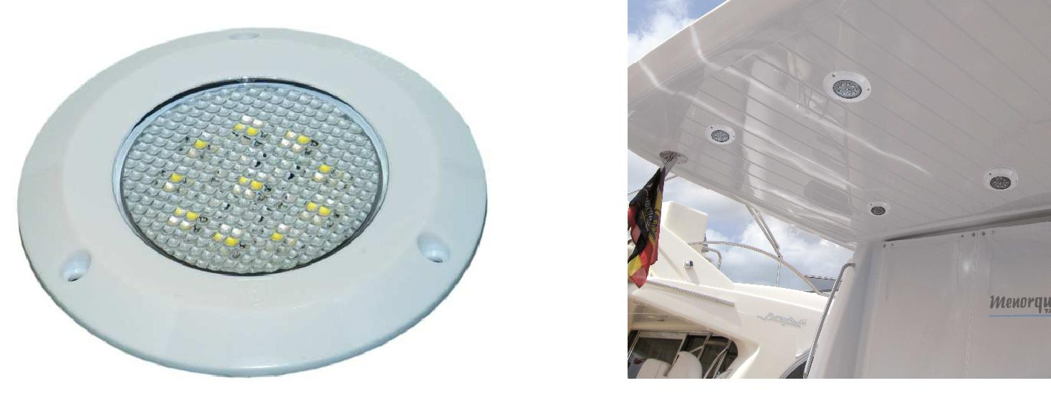

IRIS IE, LED spotlights for interiors / exteriors, with white, red, blue courtesy light

LED spotlights with two colours in polycarbonate. Strong and elegant they are suitable for internal and external environments. Intense and uniform lighting with wide ray. White, red or blue Courtesy light color (emergency). Interchangeable frame for surface and recessed mounting, available in white, black or chromed colours. Suitable for baths, kitchens, cockpits, motor vains, piers and roll bar. The low consumption allows to use them in high autonomy emergency plants. Always supplied in standard execution with two white recessed or surface frames

Technical specifications Dimensions

- Polycarbonate case (inox option)

- Emission angle 20°
• White main light, white or blue or red courtesy light. • Neutral white light 4500°K
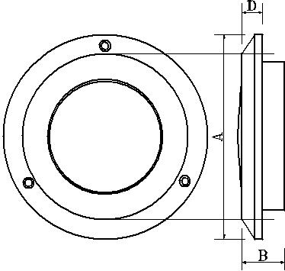
• Power Supply: 10…30 Vdc • Protection class: IP44 o IP65
• Luminous intensity: 55 lux a 1 m

• Protected against polarity inversion • Protected against power surges

• Power consumption: 4 W lighting, courtesy 0,5 / 1 W • Input for external dimmer (option D)

- Work life: 30.000 hours @ 25°C

- Dimensions: 110 (A) x 25 (C) x 85 (B) x 11mm (D)

Models | Description | Models | Description
LIR72KWW | Spotlight for interiors, white light, and white courtesy. | AV0404 | White recessed frame (supplied)
LIR72KWB | Spotlight for interiors, white light, and blue courtesy. | AV0405 | White surface frame (supplied)
LIR72KWR | Spotlight for interiors, white light, and red courtesy | AV0407 | Black recessed frame
LIR82KWW | Spotlight for exteriors, white light, and white courtesy | AV0408 | Black surface frame
LIR82KWB | Spotlight for exteriors, white light, and blue courtesy | AV0409 | Chromed recessed frame
LIR82KWR | Spotlight for exteriors, white light, and red courtesy | AV0410 | Chromed surface frame
D | Input from dimmer (ACD001) | AV0427 | AISI316 stainl.steel surface frame

Binding Union srl – via Cuorgnè, 21 – 10156 Torino – Italy – tel. +39.011.2625414 – Fax +39.011.2625428 –www.binding.it – 5

LAMPS
IRIS - LED recessed spotlight, also in UNI-EN-81-71 anti-vandal performance
Applications
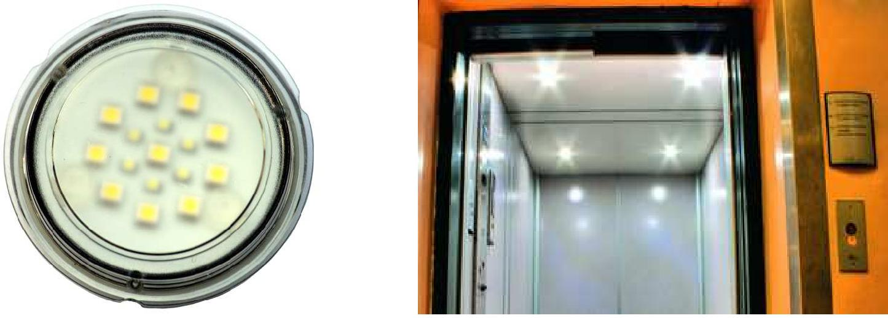

IRIS, LED spotlight for interiors, with emergency light, also in anti-vandal

Integrated emergency light, with separated circuit. They are suitable to light lift cars (two are enough to light according to the energy/safety regulation a 1000 x 1300 mm surface), goods lift, car lift, electric panels, elevator shafts and engine rooms. Elegant and strong, they are studied for applications in stiff ambiences and public installations; the LIR1040K model is up to the anti-vandal rules (UNI EN81-71, category 2) as it is fire and hit resistant.
Picture 1 shows one of the equipment used for tests.

Technical specifications Fig. 1 – Mechanical stress

- Polycarbonate case

- Plastic frame white, black or chrome (option)

- Emission angle: 120°

- Main light: 10 led (6 emergency led)

- Neutral white light 4500°K

- Power supply: 10…30 Vdc

- Mounting: wall or recessed

- Dimensions: 85(A) x 65(B) x 76(C), 89(D) x 12(F) x 13mm(E)

- Plastic frame dimensions: 110 (A) x 25 (B) x 85mm (C)

- Protection class: IP68 frontal, IP44 back

- Light intensity: 65 Lux a 1 m

- Protected against power surges

- Power consumption: 5 W complete (1W emergency)

- Operative life: 30.000 hours at 25°C
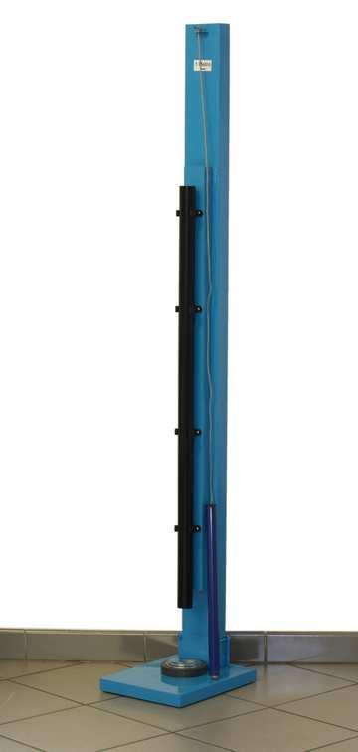
 |  | Dimensions |  | Dimensions with frame |  |  | Back fixing
 | Models | Description |  |  | Models |  | Description
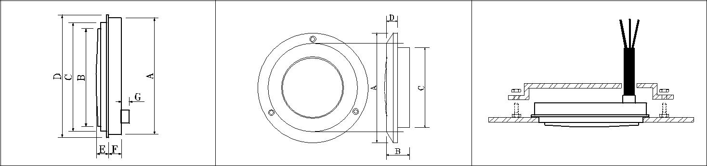  LIR1040K |  |  | Anti-vandal performance spotlight, only central body |  |  | AV0408 |  | Black surface frame
AV0404 |  |  | White recessed frame |  |  | AV0409 |  | Chrome recessed frame
AV0405 |  |  | White surface frame |  |  | AV0410 |  | Chrome surface frame
AV0407 |  |  | Black recessed frame |  |  | AV0427 |  | Cornice da parete inox

Binding Union srl – via Cuorgnè, 21 – 10156 Torino – Italy – tel. +39.011.2625414 – Fax +39.011.2625428 –www.binding.it – 6

